THE PRESIDENT’S OFFICE
REGIONAL ADMINISTRATION AND LOCAL GOVERNMENT
LONAE PRE-MOCK JOINT EXAMINATION
FORM FOUR
BASIC MATHEMATICS MARKING SCHEME
CODE; 041
TIME; 3 HRS
INSTRUCTIONS
- This paper consists of section A and B with total of 14 questions
- Answer all questions in both sections $A$ and $B$
- Mathematical table may be used if necessary

SECTION A: ($60$ Marks)
Answer all questions in this section
- $\left(a\right) let X=0.\dot{2}\dot{5}$
$$100x=25$$
$$100x$$
$$\frac{x}{99x}=\frac{0.\dot{2}\dot{5}}{25}$$
$$\frac{99x}{99}=\frac{25}{99}$$
$x=\frac{25}{99} …………..(a)$ 01 MARK
$$let X=0.\dot{5}$$
$$10x=5$$
$$10x$$
$$\frac{x}{9x}=\frac{0.\dot{5}}{5}$$
$$\frac{9x}{9}=\frac{5}{9}$$
$x=\frac{5}{9} …………..(b)$ 01 MARK
$$\frac{a}{b}=\frac{25}{99}÷\frac{5}{9}$$
$=\frac{25 }{99} x \frac{9}{5} = \frac{5}{ 5}$ 01 MARK
(b) i 0.0021 to 2sf 01 MARK
ii 8 to the nearest whole number 01 MARK
iii 2.8 to 1dp 01 MARK

- (a) $\frac{2}{2\sqrt{3}+\sqrt{2}}×\frac{2\sqrt{3}-\sqrt{2}}{2\sqrt{3}-\sqrt{2}}$ 01 MARK
$=\frac{4\sqrt{3}-2\sqrt{2}}{({2\sqrt{3})}^{2}-({\sqrt{2})}^{2}}$
$=\frac{4\sqrt{3}-2\sqrt{2}}{12-2}$
$=\frac{4\sqrt{3}-2\sqrt{2}}{10}=\frac{2\sqrt{3}-\sqrt{2}}{5}$
$=\frac{2\sqrt{3}-\sqrt{2}}{5}$ 02 MARKS

(b) $\frac{2^{3x+7}}{4^{2x-2}}=\frac{8^{x-3}}{{32}^{x-5}}$
$\frac{2^{3x+7}}{2^{2(2x-2)}}=\frac{2^{3(x-3)}}{2^{5(x-5)}}$ 02 MARKS
$2^{3x+7-(4x-4)}=2^{3x-9-(25-5x)}$
$-x+11=8x-34$
$x=5$ 01 MARK

- (a)
- $M^{'}=\{f, b, k, c, j\}$
$N=\{f, b, k, d, h\}$ $01\frac{1}{2}$ MARKS
$∴$ $M^{'}∩N=\{f, b, k\}$
- $n\left(M^{'}∪N^{'}\right)=?$
But $M^{'}=\{f, b, k, c, j\}$ and $N^{'}=\{a, e, i, c, j\}$
$\left(M^{'}∪N^{'}\right)=\{f, b, k, c, j,$ $a, e, i, c, j\}$ $01\frac{1}{2}$ MARKS
$∴n\left(M^{'}∪N^{'}\right)=8$

(b) let the Black Bak be B
the white Bak be W.
P(W) =$4/9$
P(B) =$5/9$
By tree diagram.

$$4/9$$
$$5/9$$
$$3/8$$
$$3/8$$
$$4/8$$
$$4/8$$
W
W
W
B
B
B
WW
WB
BW
BB
1MARK
(i) The probability that both are white balls $P(WW)= 4/9x3/8=1/6$ 1MARK
(ii) The probability that the first is black and the second is the white ball
$P(BW)= 5/9x4/8=5/{18}$
The probability that the first is black ball and the second is the white is $5/{18}$ 1MARK

- (a)
- Solve for V=$2\underline{a}+3\underline{b}$
V=$2(3\underline{i}+4\underline{j})+3(-2\underline{i}+6\underline{j})$
V=6$\underline{i}+8\underline{j}-6\underline{i}+18\underline{j}$
V=$0\underline{i}+26\underline{j}$ =$26\underline{j}$ 02 MARKS

- Find magnitude of V
|V|=$\sqrt{0^{2}+{26}^{2}}$=26 01 MARK
(b) (i)
Slope1 = Slope2
$\frac{5-3}{k+2}=\frac{2-0}{6-k}$
(k+2) x 2 = 2 x (6-k)
2k+4 = 12-2k
4k=8 $01\frac{1}{2}$ MARK
K=2
(ii)
$d=\sqrt{{\left(x_{1}-x_{2}\right)}^{2}+{\left(y_{1}-y_{2}\right)}^{2}}$
$d=\sqrt{{\left(9-1\right)}^{2}+{\left(5+1\right)}^{2}}$ $01\frac{1}{2}$ MARK
$d=\sqrt{64+36}$
d= 10

- (a) $2w=l+3$…………(i)
$36=2l+2w$
$\frac{36}{2}=\frac{2}{2}(l+w)$
$18=l+w$ ……(ii) 01 MARK
Solve equation (i) and (ii)
$+\left\{\begin{matrix}2w-l=3 \\ w+l=18\end{matrix}\right.$ 01 MARK
$w=7$ and $l=11$
$∴$ width is $7cm$ and length is $11cm$ 01 MARK
(b) $\left(n-2\right)180°=sum of interior angle$
$\left(n-2\right)\frac{180°}{180°}=\frac{1080°}{180°}$ 02 MARKS
$n-2=6$
$n=8$ 01 MARK
$∴$ Number of sides is $8$
- (a) $y∝\frac{x-1}{x+d}$
$y=\frac{k(x-1)}{x+d}$
$k=\frac{y(x+d)}{x-1}$
$x=2, d=4, y=1$
$k=\frac{1(2+4)}{2-1}$
$k=6$ 01 MARK

$∴$ $y=\frac{6(x-1)}{x+d}$
From $y=\frac{k(x-1)}{x+d}$
$y=2, d=1, k=6$
$2=\frac{6(x-1)}{x+1}$ 01 MARK
$2\left(x+1\right)=6(x-1)$
$2x+2=6x-6$
$4x=8$
$∴$ $x=2$ 01 MARK

(b) $How many grams are there in 0.00912 tones$.
From 1 tonne = 1000kg 02 MARK
0.00912 tones = 0.00912 x 1000kg
= 9.12 kg
But 1kg = 1000g
9.12kg = 9.12kg x1000
=9120 grams 01 MARK

- (a) $L:M=2:1$ and $M:N=3:4$
Required $N:L$
$\frac{L}{M}=\frac{2}{1}$ ………….. (i)
$\frac{M}{L}=\frac{3}{4}$………..…. (ii)
Make $M$ the subject in equation (i) and substitute into (ii)
$M=\frac{L}{2}$ 02 MARKS
$\frac{L}{2N}=\frac{3}{4}$
$\frac{N}{L}=\frac{2}{3}$
$N:L=2:3$
$∴$ $N:L=2:3$ 01 MARK

(b) Define the following; (i) Double entry (ii) Transaction (iii) Assets @ 01 MARK
- Double entry is the process of recording business transaction twice
- Transaction is the movement of money or goods or services valued in terms of money worth from one part/ to another.
- Assets are possession of a business.

- (a) Solution
Given $A_{5}=40$ $A_{7}=20$
$$d=?$$
$$A_{5}=A_{1}+4d$$
$$A_{7}=A_{1}+6d$$
$A_{1}+4d=40$ ……..i
$A_{1}+6d=20$ ……..ii 1MARK
Solve i and ii simultaneously
In equation i
$A_{1}=40-4d$……iii
Substitute eqn iii into ii
$$40-4d+6d=20$$
$$2d=20-40$$
$$2d=-20$$
$$d=\frac{-20}{2}$$
$$d=-10$$
Then from iii $A_{1}=40-4\left(-10\right)=80$
$$A_{1}=80$$
$∴$ Common difference$=-10$ 1MARK

b) Solution
$$A_{10}=A_{1}+9d$$
$$A_{10}=80+9\left(-10\right)$$
$=80-90=-10$ 1MARK
$∴$ $A_{10}=-10$

(b) Given R = 10%
(i) After two years he got 5000
To find the amount harvested
$A=P{(1+\frac{R}{100})}^{n}$ 0.5MARK
$$5000=P{(1+\frac{10}{100})}^{2}$$
$$5000=P{(1+0.01)}^{2}$$
$$5000=P{(1.01)}^{2}$$
$$\frac{5000}{{1.01}^{2}}=P$$
$\frac{5000}{1.0201}=P$ 0.5 MARK
4901.481/= is the amount invested. 1MARK

(ii) At the end of two years, he received an interest of
=5000-4901.48
=98.52/=
At the end of two years he received an interest of 98.52/= 1MARK

- (a) Find the length of $AB$ in figure below
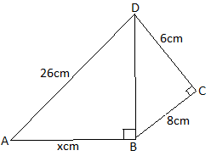
Solution
$∆BCD$ is a right angled triangle
${BD}^{2}=8^{2}+6^{2}$ by Pythagoras theorem
$${BD}^{2}=8^{2}+6^{2}={100 cm}^{2}$$
$∆ABD$ is right angled
$${26}^{2}=x^{2}+100$$
$$x^{2}=676-100$$
$$x^{2}=576$$
$$x=24$$
$∴$ $\overline{AB}=24cm$

(b) Find unknown sides and angles in $∆ABC$ in which $a=22.3cm, \hat{B}=86°$ and $\hat{A}=26°$.
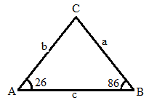
$\hat{A}+\hat{B}+\hat{C}=180°$
$26°+86°+\hat{C}=180°$
$C=68°$
From sine rule
$\frac{\sin{A}}{a}=\frac{\sin{B}}{b}=\frac{\sin{C}}{c}$
$\frac{\sin{26}}{22.3}=\frac{\sin{86}}{b}=\frac{\sin{68}}{c}$
$\frac{\sin{26}}{22.3}=\frac{\sin{86}}{b}$
$b=\frac{22.3×0.9976}{0.4384}$
$b=50.7$
Again
$\frac{\sin{B}}{b}=\frac{\sin{C}}{c}$
$\frac{\sin{86}}{50.7}=\frac{\sin{0.9272}}{c}$
$c=\frac{50.7×0.9272}{0.9976}$
$c=47.2$
$∴$ $\hat{C}=68°, b=50.7cm$ and $c=47.2cm$

- (a) $a^{2}+b^{2}=60$………..(i)
$({a-b)}^{2}=48$……………(ii)
From equation ii
$({a-b)}^{2}=a^{2}-2ab+b^{2}$ 01 MARK
$2ab=a^{2}+b^{2}-({a-b)}^{2}$
Substitute the value of equation (i) and (ii) into $2ab=a^{2}+b^{2}-({a-b)}^{2}$
$2ab=60-48$ 01 MARK
$ab=6$
$∴$ $ab=6$ 01 MARK

(b)Let the consecutive even number be $x$ and $y$
The product is $80$
$xy=80$ ………………(i)
The difference between the even number is $2$
$y-x=2$ …………………….(ii)
Then $y=2+x$ substitute into equation (i)
$x\left(2+x\right)=80$ 01 MARK
$x^{2}+2x-80=0$
Solve the value of $x$ by splitting the middle term
$\left(x^{2}+10x\right)-\left(8x+80\right)=0$
$x\left(x+10\right)-8\left(x+10\right)=0$ 01 MARK
$\left(x-8\right)\left(x+10\right)=0$
Either $x-8=0$ or $x+10=0$
$x=8$ and $x=-10$
From $y=2+x$
When $x=8$ $y=2+8=10$
When $x=-10$ $y=2-10=-8$
$∴$ Consecutive two even numbers are $8$ and $10$ 01 MARK

SECTION B: (40 Marks)
Answer all questions in this section
- (a)
02 MARKS
$$C.I$$ | $$f$$ | $$x$$ | c.f | Upper r. limit
$$11-15$$ | $$4$$ | $$13$$ | $$4$$ | $$15.5$$
$$16-20$$ | $$8$$ | $$18$$ | $$12$$ | $$20.5$$
$$21-25$$ | $$20$$ | $$23$$ | $$32$$ | $$25.5$$
$$26-30$$ | $$21$$ | $$28$$ | $$53$$ | $$30.5$$
$$31-35$$ | $$12$$ | $$33$$ | $$65$$ | $$35.5$$
$$36-40$$ | $$3$$ | $$38$$ | $$68$$ | $$40.5$$
 | $$\sum{f}=68$$

$Mode=L+\left(\frac{t_{1}}{{t_{1}+t}_{2}}\right)i$ 01 MARK
$Mode=25.5+\left(\frac{1}{1+9}\right)5$
$Mode=25.5+\left(\frac{1}{10}\right)5$
$Mode=26$ 01 MARK

- Diagram 03 MARKS, Estimation 01 MARK
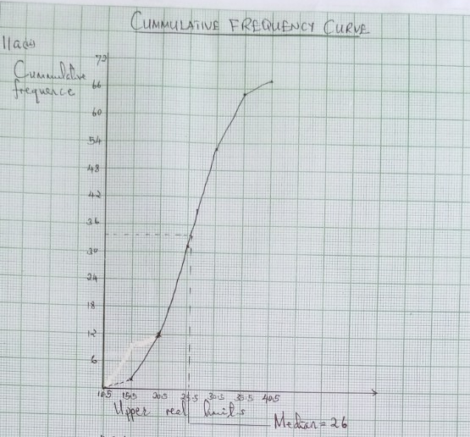

(b) Find the angle x in the figure below
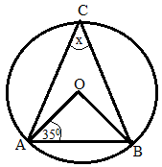
$$∆AOB is an Isocles$$
$$\overline{OA}=\overline{OB}=r (radii)$$
$∆AOB= ∆OBA$ (Base angle of an isosceles ) 0.5 MARK
$$∆OAB= ∆OBA=35$$
Thus $∆OAB+ ∆OBA+∆AOB=180$
$$35+ 35+∆AOB=180$$
$∆AOB=110$ 0.5 MARK
But $∆AOB= 2∆ACB$
$$∆ACB=x$$
$$∆AOB=2x$$
$\frac{110}{2}=\frac{2x}{2}$ x = ${55}^{o}$
Therefore the value of $∆x= {55}^{o}$ 1 MARK

- (a)Given $B={30}^{O}W θ={40}^{O}S, R=6376kmπ= 3.14 and distance=1000km$
Distance =$\frac{(α-β)πRCosθ}{180}$ 0.5MARK
1000km =$\frac{\left(α-{30}^{o}\right)x3.14x6370kmxCos40}{180}$ 1MARK
$α-{30}^{o}=\frac{1000km x180}{3.14x6370kmxCos40}$ 1MARK

$$α-{30}^{o}=\frac{1000km x180}{3.14x6370kmx0.7660}$$

$α-{30}^{o}={11.7}^{o}$ 0.5 MARK

$$α={{30}^{o}+11.7}^{o}$$
$${=41.7}^{o} ≅ 42 W$$
The location of point B is (${40}^{o}$s 42w) 1MARK

(b) (i) The angle between VA and the base ABCD
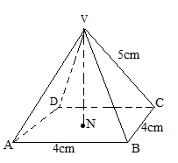
We need to find the distance $\overline{AN}and \overline{VN}$
Consider $∆ABD$
$${\overline{AB}}^{2}+{\overline{BC}}^{2}={\overline{AC}}^{2}$$
$AC=\sqrt{{\overline{AB}}^{2}+{\overline{BC}}^{2}}$ 1MARK
$$=\sqrt{4^{2}+4^{2}}$$
$$=\sqrt{32}$$
$=4\sqrt{2}$cm 1MARK
$$AN=1/2×AC$$
$$=1/2×4\sqrt{2}$$
$$AN=2\sqrt{2}$$
Consider triangle VAN
$${AN}^{2}+{VN}^{2}={AV}^{2}$$
$$\overline{VN}=\sqrt{{AV}^{2}-{AN}^{2}}$$
$$=\sqrt{5^{2}-{(2\sqrt{2})}^{2}}$$
$$=\sqrt{25-8}$$
$$=\sqrt{17}$$
$VN=4.123$ 1MARK

From triangle VAN, The angle VA makes with the base
$$\tan{θ=\frac{VN}{AN}}$$
$=\frac{\sqrt{17}}{2\sqrt{2}}$
$$\tan{θ=1.4577}$$
$$θ=\tan^{-1}(1.4577)$$
$θ={55.6}^{o}$ 1MARK
(ii)The volume of the pyramid
$V=1/3×Base area ×height$ 1MARK
$$1/3×4cm ×4cm×4.123$$
$$=21.98{cm}^{3}$$
The volume of the pyramid is $21.98{cm}^{3}$ 1MARK

- (a) Given that $A=\left(\begin{matrix}2 & -3 \\ -1 & 2\end{matrix}\right)$ and $B=\left(\begin{matrix}-2 & 6 \\ 1 & 2\end{matrix}\right)$.
- 2A+B-5I=$2\left(\begin{matrix}2 & -3 \\ -1 & 2\end{matrix}\right)+\left(\begin{matrix}-2 & 6 \\ 1 & 2\end{matrix}\right)-5\left(\begin{matrix}1 & 0 \\ 0 & 1\end{matrix}\right)$
=$\left(\begin{matrix}4 & -6 \\ -2 & 4\end{matrix}\right)+\left(\begin{matrix}-2 & 6 \\ 1 & 2\end{matrix}\right)-\left(\begin{matrix}5 & 0 \\ 0 & 5\end{matrix}\right)$
=$\left(\begin{matrix}-3 & 0 \\ -1 & 1\end{matrix}\right)$ 02 MARKS
- Determine the determinant of matrix in (a) (i) above
$$\left|\left(\begin{matrix}-3 & 0 \\ -1 & 1\end{matrix}\right)\right|=\left(-3x1\right)-\left(-1x0\right)$$
$=-$3 01 MARK
(b) $x+3y=5$ and $2x+8y=12$
$\left(\begin{matrix}1 & 3 \\ 2 & 8\end{matrix}\right)\left({x \atop y}\right)=\left({5 \atop 12}\right)$
${\left(\begin{matrix}1 & 3 \\ 2 & 8\end{matrix}\right)}^{-1}=\frac{1}{8-6}\left(\begin{matrix}8 & -3 \\ -2 & 1\end{matrix}\right)$
$=\left(\begin{matrix}4 & -3/2 \\ -1 & 1/2\end{matrix}\right)$ 02 MARKS
$$Pre multiplying by inverse \left(\begin{matrix}4 & -3/2 \\ -1 & 1/2\end{matrix}\right)$$
$\left(\begin{matrix}4 & -3/2 \\ -1 & 1/2\end{matrix}\right) \left(\begin{matrix}1 & 3 \\ 2 & 8\end{matrix}\right)\left({x \atop y}\right)=\left(\begin{matrix}4 & -3/2 \\ -1 & 1/2\end{matrix}\right) \left({5 \atop 12}\right)$ 01 MARK
$\left({x \atop y}\right)=\left(\begin{matrix}4 & -3/2 \\ -1 & 1/2\end{matrix}\right) \left({5 \atop 12}\right)$
$\left({x \atop y}\right)= \left({\left(4x5\right)+(-3/2x12) \atop \left(-1x5\right)+(\frac{1}{2} x 12)}\right)$
$\left({x \atop y}\right)= \left({\left(4x5\right)+(-3/2x12) \atop \left(-1x5\right)+(\frac{1}{2} x 12)}\right)$
$\left({x \atop y}\right)= \left({20-18 \atop -5+6}\right)=\left({2 \atop 1}\right)$
Therefore x=2 and y=1 01 MARK

(c) $\left({x^{'} \atop y^{'}}\right)=\left(\begin{matrix}Cos 2x45 & Sin 2x45 \\ Sin 2x45 & -Cos 2x45\end{matrix}\right)\left({4 \atop 3}\right)$ 01 MARK
$\left({x^{'} \atop y^{'}}\right)=\left(\begin{matrix}Cos 90 & Sin 90 \\ Sin 90 & -Cos 90\end{matrix}\right)\left({4 \atop 3}\right)$
$\left({x^{'} \atop y^{'}}\right)=\left(\begin{matrix}0 & 1 \\ 1 & 0\end{matrix}\right)\left({4 \atop 3}\right)$
$\left({x^{'} \atop y^{'}}\right)=\left({3 \atop 4}\right)$ 01 MARK
Image after translatio
$\left({x^{''} \atop y^{''}}\right)=\left({-2 \atop 2}\right)+\left({3 \atop 4}\right)$
$\left({x^{''} \atop y^{''}}\right)=\left({-2+3 \atop 2+4}\right)$
$\left({x^{''} \atop y^{''}}\right)=\left({1 \atop 6}\right)$
Hence the image is (1, 6) 01 MARK

- (a) A function $f\left(x\right)=\left\{\begin{matrix}x if-3≤x<3 \\ x^{2} if-3≤x<5 \\ 5 if x≥5\end{matrix}\right.$
- Draw the graph of $f\left(x\right)$
- State the domain and range
- Find $f(10)$
- (a) (i) Case I
$y=x$ for $x=-3,-2,-1,0,1,2,3$
$$x$$ | $$-3$$ | $$-2$$ | $$-1$$ | $$0$$ | $$1$$ | $$2$$ | $$3$$
$$y=x$$ | $$-3$$ | $$-2$$ | $$-1$$ | $$0$$ | $$1$$ | $$2$$ | $$3$$

Case II
$y=x^{2}$ for $x=-3,-2,-1,0,1,2,3,4,5$
$$x$$ | $$-3$$ | $$-2$$ | $$-1$$ | $$0$$ | $$1$$ | $$2$$ | $$3$$ | $$4$$ | $$5$$
$$y=x^{2}$$ | $$9$$ | $$4$$ | $$1$$ | $$0$$ | $$1$$ | $$4$$ | $$9$$ | $$16$$ | $$25$$

Case II
$y=5$ for $x=5,6,7$
$$x$$ | $$5$$ | $$6$$ | $$7$$
$$y=5$$ | $$5$$ | $$6$$ | $$7$$
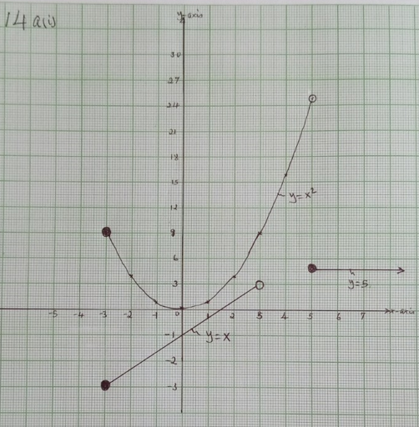 02 MARK

(ii)Domain$=\{x:x≥-3\}$ 01 MARK
Range$=\{y:-3≤y<25\}$ 01 MARK
(iii) $f\left(10\right)=5$ 01 MARK

(b) Solution
Constraints
4x + y ≥ 8
x + y ≥ 5 01 MARK
2x +7y ≥ 20
x ≥ 0 and y ≥ 0
Objective function
f(x,y) = 70x + 90y
from (i)equation
4x + y =8
Table of value
x | 0 | 2
y | 8 | 0

From the equation (ii)
X + y ≥ 5
Table of value
X + y = 5
x | 0 | 5
y | 5 | 0

From the equation (iii)
2x +7y ≥20
Table of value
2x +7y =20
x | 0 | 10
y | 2.9 | 0

Graph…………..02 mark
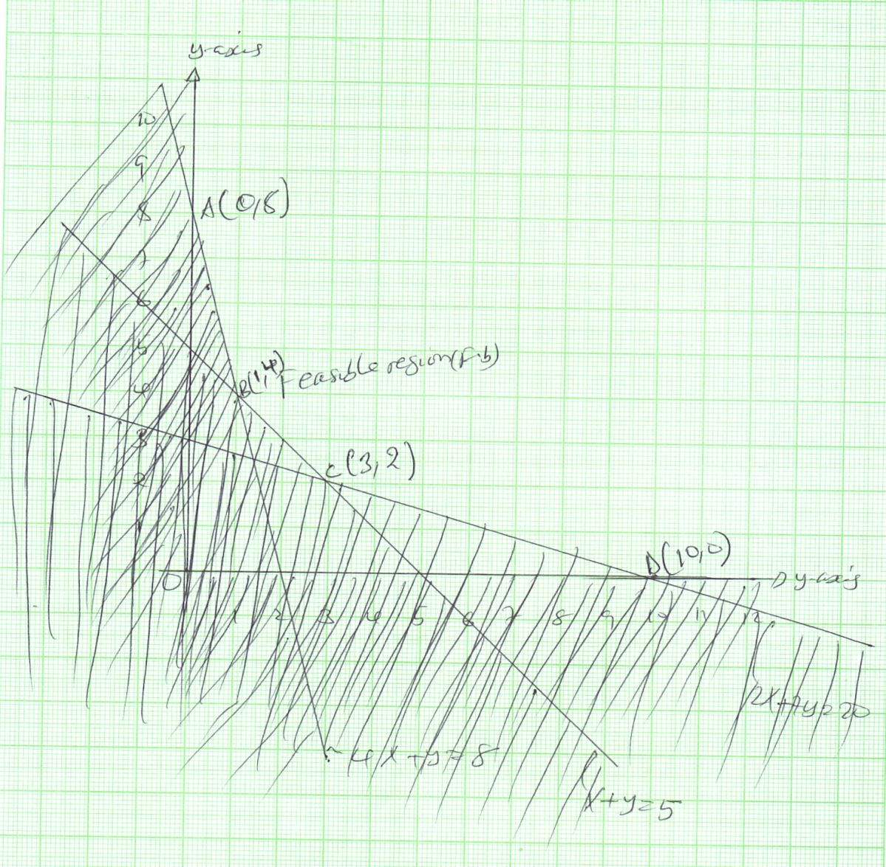

refers to the graph
01 mark
Corner points | Objective functions f(x,y) =70x + 90y | Total value
A(0,8) | F(x,y)=70(0) + 90(8) | 720
B(1,4) | F(x,y) =70(1) + 90(4) | 350
C(3,2) | F(x,y) =70(3) + 90(2) | 390
D(10,0) | F(x,y) =(70(10) + 90(0) | 700

The lowest cost if the minimum of daily requirement is 350/=………………………..……………. 01 mark

